PES UNIVERSITY
Computer Science and Engineering
LAB 2 – JIRA HANDS-ON
Agile Backlog Creation & Sprint Simulations
Project: Community Lost & Found Matching Network
Name | ________Ramitha R____________________
SRN | ____________PES1UG24CS368________________
Section | ______________________F______
Date | 08 September 2026

1. Objective
To use Jira to convert the functional requirements of the Community Lost & Found Matching Network into an Agile backlog, estimate and prioritize User Stories, simulate two sprints, and analyse progress using Burndown Charts.

2. Agile Backlog – Epics and User Stories
Epic | User Story | Priority | Story Points
Item Reporting | CLFMN-8 – Report a lost item | High | —
Item Reporting | CLFMN-9 – Report a found item | High | 5
Item Tag Extraction | CLFMN-10 – Extract item tags | High | 8
Lost & Found Matching | CLFMN-11 – Match lost and found items | High | 8
Match Notifications | CLFMN-12 – Receive match notification | High | 3
Ownership Verification | CLFMN-13 – Claim matched item | High | 3
Ownership Verification | CLFMN-18 – Verify ownership with security questions | High | —
Suspicious Claim | CLFMN-20 – Flag suspicious claim | Medium | 5
Community Moderation | CLFMN-16 – Moderate suspicious reports | Medium | 5
Note: The Jira backlog contained a few duplicate/unfinished items and some stories without Story Points. The sprint simulations used the estimated items shown in the sprint sections below.

3. User Story Details
Report a lost item: As an Owner, I want to report a lost item with its details, so that the system can search for potential matches.
Report a found item: As a Finder, I want to report a found item with relevant item details, so that the system can identify its potential owner.
Extract item tags: As a user, I want the system to extract visual and text tags from an item report, so that items can be described consistently for matching.
Match lost and found items: As an Owner, I want the system to match my lost item with relevant found item reports based on item characteristics and location, so that I can identify a possible match.
Receive match notification: As an Owner, I want to receive a notification when a potential match is found, so that I can review the found item and decide whether to claim it.
Claim matched item: As an Owner, I want to claim a matched found item, so that I can begin the ownership verification process.
Verify ownership with security questions: As an Owner, I want to answer the finder's private security questions, so that my ownership can be verified before contact details are revealed.
Flag suspicious claim: As the system, I want to flag claims that repeatedly fail ownership verification, so that potentially suspicious claims can be reviewed.
Moderate suspicious reports: As a Community Admin, I want to review suspicious claims and reports, so that potentially fraudulent or inappropriate activity can be handled.

4. Story Point Estimation
Fibonacci-style Story Points were used to represent relative effort, complexity, and uncertainty. The estimates used for the sprint work were 3, 5, and 8 points.
Story Point | Example | Rationale
3 | Receive match notification / Claim matched item | Relatively simple workflow
5 | Report item / Flag suspicious claim / Moderate reports | Moderate effort and workflow
8 | Extract tags / Match items / Ownership verification | Higher complexity, uncertainty, or integration effort

5. Sprint 1 Simulation
Sprint duration: 1 week
Sprint 1 planned workload: 24 Story Points.
Issue | User Story | Points | Final Sprint 1 Status
CLFMN-17 | Report a lost item | 5 | Done
CLFMN-10 | Extract item tags | 8 | Done
CLFMN-9 | Report a found item | 5 | In Progress
CLFMN-12 | Receive match notification | 3 | In Progress
CLFMN-13 | Claim matched item | 3 | In Progress
Completed in Sprint 1: 13 points. Remaining: 11 points.

6. Sprint 1 Burndown Chart Screenshot
[ INSERT JIRA SPRINT 1 BURNDOWN CHART SCREENSHOT HERE ]
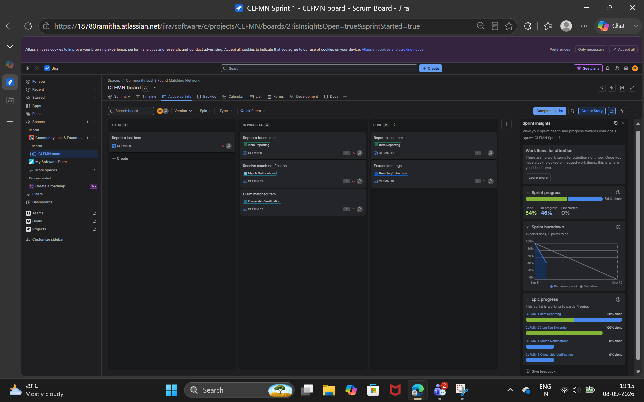

7. Sprint 2 Simulation
Sprint 2 continued unfinished work and added estimated backlog items. The simulation used the following six estimated stories.
Issue | User Story | Points | Final Sprint 2 Status
CLFMN-9 | Report a found item | 5 | In Progress
CLFMN-12 | Receive match notification | 3 | In Progress
CLFMN-13 | Claim matched item | 3 | In Progress
CLFMN-11 | Match lost and found items | 8 | Done
CLFMN-20 | Flag suspicious claim | 5 | Done
CLFMN-16 | Moderate suspicious reports | 5 | In Progress
Sprint 2 completed: 13 points. Remaining: 16 points. Total estimated work represented in Sprint 2: 29 points.

8. Sprint 2 Burndown Chart Screenshot
[ INSERT JIRA SPRINT 2 BURNDOWN CHART SCREENSHOT HERE ]
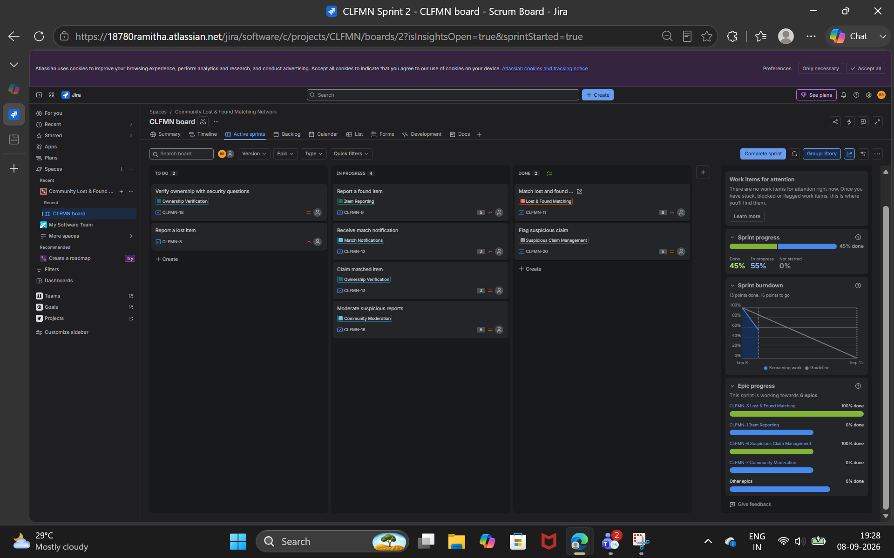

9. Reflection
1. Did the estimations reflect the actual effort?
The Fibonacci Story Point estimates generally reflected the relative complexity of the work. Simpler tasks such as notifications were estimated lower, while tagging, matching, and ownership verification were given higher estimates.
2. Was the backlog well-prioritized?
Yes. The major functional requirements were converted into Epics and User Stories and prioritized so that core reporting, matching, notification, and ownership functions could be addressed first.
3. How did the simulated sprint align with the plan?
The sprint simulation followed the planned workflow of moving items from To Do to In Progress and then Done. Some items remained unfinished, demonstrating that sprint completion depends on available team capacity.
4. What insights did the Burndown Chart give about team capacity?
The Burndown Chart showed how completed work reduced the remaining Story Points. In Sprint 2, 13 points were completed while 16 points remained, showing that progress was made but the entire planned workload was not completed.
Other screenshots : 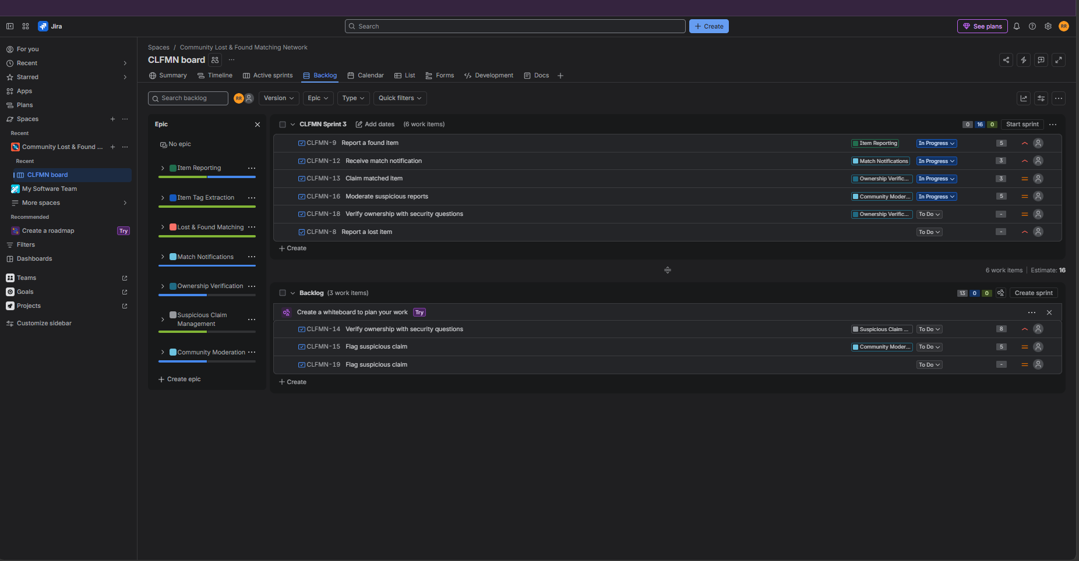
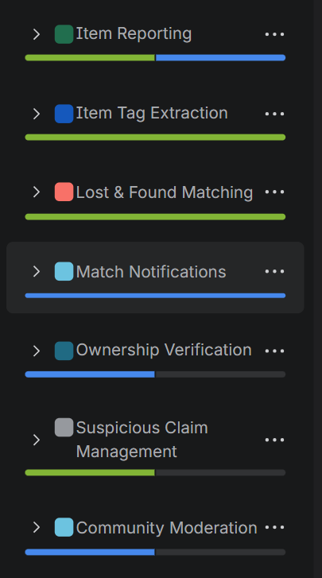
EPICS :
